**Exercise 1**

**Part A: Introduction to QGIS Raster and Vector Layers**

This exercise will provide a brief overview of QGIS elements. Part A will also show you how to add vector data and modify layer attributes. Part B will show you how to compose a well-designed map with all standard map elements (title, legend and scale bar)

**Data Requirements**

For this exercise you will need all files from the “Exercise1_Data” zipped folder on the Canvas website including:

• CA_projected.shp

• CA_Cities_Top10.shp

• Yosemite_boundary.shp

You will need to unzip this folder and save it to a folder on your computer. It is recommended that all data for this course be well organized and remain in the same location. It is also recommended that you use an external drive (500 GB or 1 TB) for storing and backing up satellite data.

**Additional Prerequisite**

QGIS 3.10.x and the associated plugins need to be downloaded and installed as part of the prerequisites for this course. If you do not have QGIS installed, please see Downloading and Installing QGIS and Plugins on the course Canvas website. Additionally, the recommended QGIS textbooks (Menke, 2019; Wegmann et al, 2020) have very useful user instructions and examples of short exercises.

**Getting Started with QGIS**

• Open QGIS

* Mac users: from your Desktop icon or your Applications folder
* Windows users: from your Desktop icon or your Program start

The QGIS interface has multiple elements outlined here:

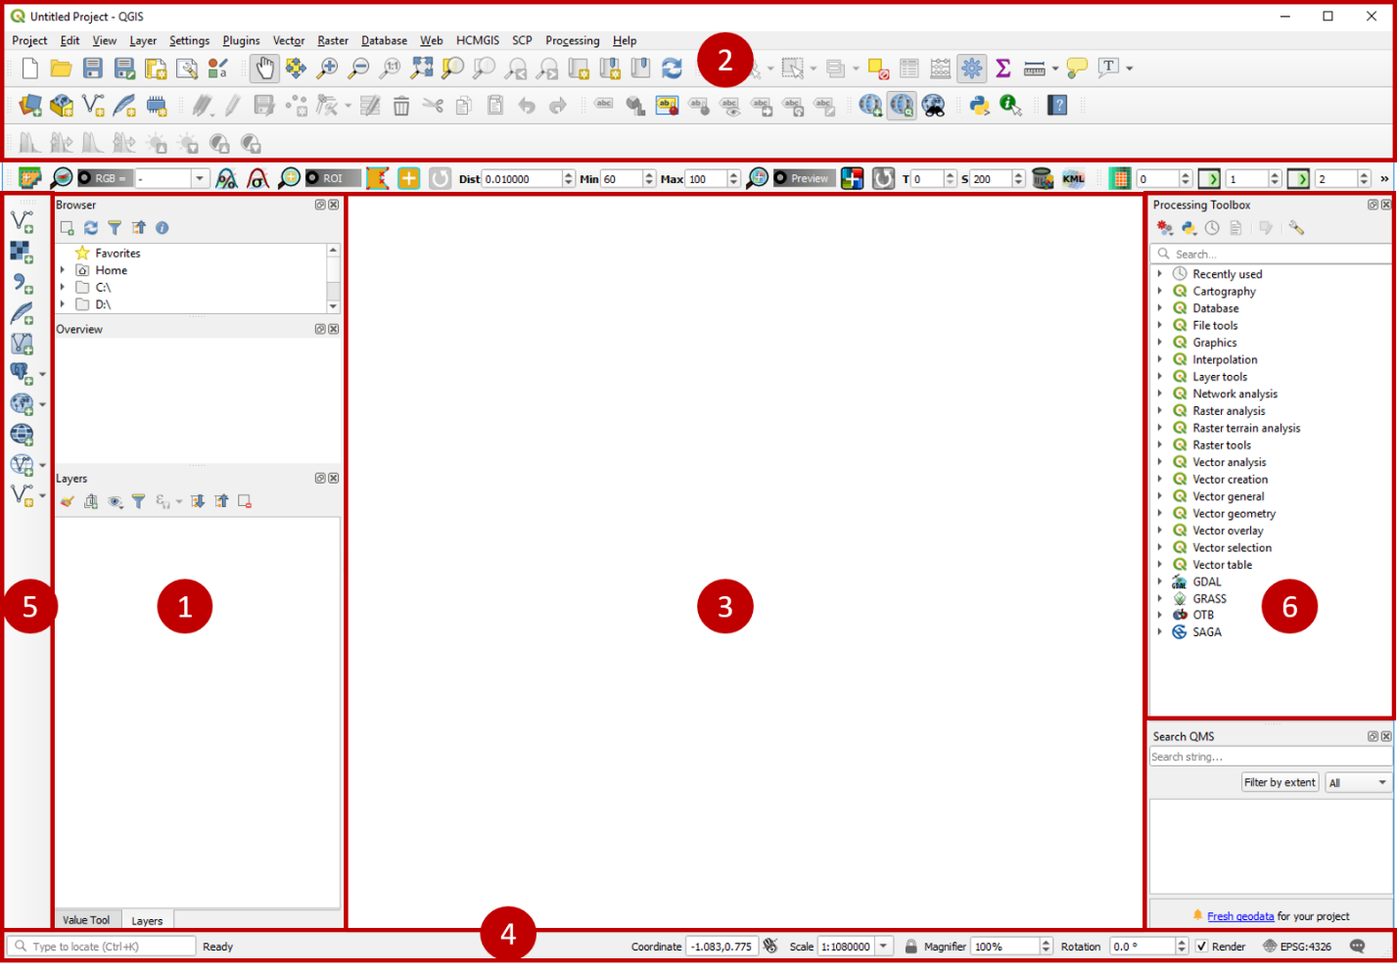

**1. Layers/Browser/Overview Panels**

This will display all the layers you have in the map. You can right click on each layer file for more information and to perform specific functions. You can also expand and collapse items within the panel. Browser and Layers panels describe where data is stored and how that data is displayed.

**2. Toolbars**

The tools you use most often can be displayed here. You can modify which tools are displayed by clicking on **View | Toolbars**. You can also move tools around within this toolbar.

**3. Map Canvas**

Where the map is displayed. It is the biggest area and reserved for displaying data.

**4. Status Bar**

This shows current information about the map and allows you to adjust the scale. There is also a search box that helps to find processing tools and layers.

**5. Manage Layers Toolbar**

Here you can add in different types of data layers such as vector or raster files, databases, web services, and text files. It also contains the tools for creating new layers. Note: if you hover over any of these icons, it will display the function name. Explore the available functions.

**6. Processing Toolbox**

This toolbox can be added by clicking **View | Panels | Processing Toolbox**. Here you will find a list of processing tools organized according to function. The search function lets you locate specific tools quickly.

Note: QGIS is highly customizable. You can do this by going to **Settings | Interface Customization**.

**Adding a vector layer**

• Click on the **Add Vector Layer** icon

• In the **Browser** window navigate and find the shapefile called CA_projected.shp. Right click on the CA_projected file nameto add it to the map or drag it into the **Layers** panel or **Map** (Canvas) window. The layer will be added to the map and you should see an outline of the state of California. The color may not be aesthetically pleasing, so we can change that.

• Right click on the CA_projected file in the Layers Panel, then click on **Properties**. This should automatically take you to the **Symbology** panel and there you can change the color, transparency, etc. You will notice some example symbols and colors on the bottom side of the Symbology panel. Click on simple green fill. Click **Apply** at the bottom. You will see the fill change colors. Click **OK**.

• Repeat the previous steps to add the CA_Cities_Top10.shp and Yosemite_boundary.shp files. These are a point file of the ten largest cities in California based on population, and the boundary of Yosemite National Park.

• Right click on the CA_Cities_Top10 file in the Layers Panel, then click on **Properties**. In the **Symbology** tab, change the symbol to the dot blue option in the bottom box. Then, using the dropdown menu next to **Color**, change the fill color to light blue.

• You can also add labels to a map and modify them based on your specific cartographic needs. Click on the **Labels** tab (in the Layer Properties box). In the top drop down menu choose **Single labels**. In the drop down menu next to **Value** select NAMELSAD. Click Apply.

• Without closing the Properties box, take a look at the city labels in the map. You can also change the formatting of the labels. Click on the **Buffer** option within the **Labels** tab. Check the **Draw text buffer** button and keep everything as default. Click on the **Shadow** option and check the Draw drop shadow. Finally, click on the **Placement** option and increase the distance to 1 millimeter by clicking on the “up” arrow next to **Distance**. Click **Apply** again and close the **Properties** window. Take a look at the labels again in the map. They are now a bit easier to read.

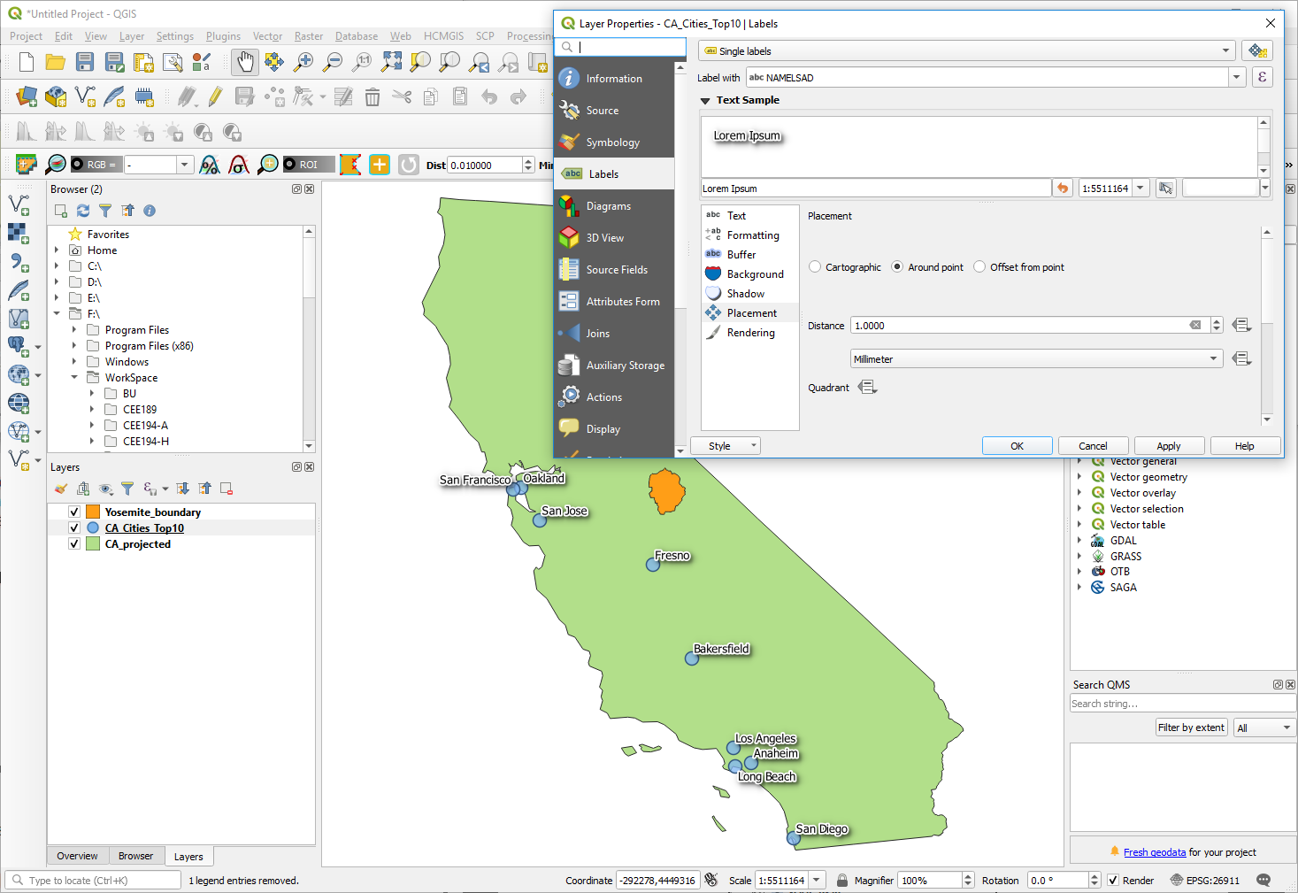

• You can also modify and label the Yosemite layer in the same way. Open the Properties box and change the color to orange. Click on **Simple** **Fill** in the fill box on the left side. Then change the Fill color to light orange and the Stroke color to dark red.

• Label the layer using the **UNIT_NAME** and give it a white **Buffer** of 0.7 millimeters.

**Viewing data and Vector Attributes**

• Using some of the tools on the top of your QGIS project panel, you can modify the view of your data. Click on the **Zoom Full** tool. This should display the full extent of all of your map layers. You can also zoom into specific layers. Click on the Yosemite_boundary layer, then click on the **Zoom to Layer** tool. This should allow you to view the full extent of the Yosemite NPS boundary. You can also zoom to a specific layer by right clicking on the layer in the Layers Panel and clicking on Zoom to Layer.

• You can obtain more information about the specifics of a vector layer by taking a look at the Attribute table. Right click on the CA_Cities_Top10 layer and click on **Open Attribute Table**. Here you will see the latitude and longitude of each point, the state, and the city name.

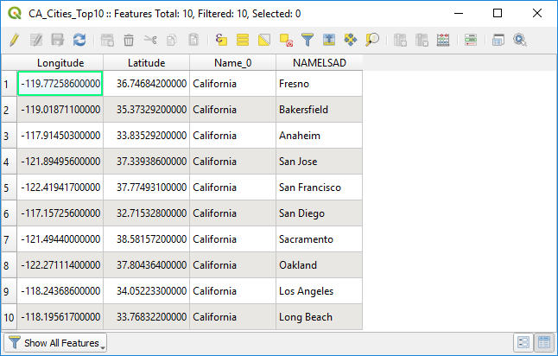

**Saving your QGIS Projects**

• It is very important to save your QGIS projects along the way so that you do not lose any important processing steps. At the top of your screen click on **Project**, then **Save As**. Navigate to your data folder for this exercise and save the project as Exercise_1 or something similar. We recommend that throughout this exercise and your homework assignments, that you regularly click on the **Save** icon .

**Using Plugins**

• You can also add some background imagery to your map using the HCMGIS Plugin. At the top of your screen (Menu toolbar) click on **HCMGIS Plugin**, then **BaseMap**, and select **Google Satellite**. (A box may appear requesting a transformation for Google Satellite; accept the default). Then move the Google Satellite layer to the bottom of the Layers Panel by clicking on Google Satellite and dragging it down below the other layers. Finally, zoom to your CA_Projected layer.

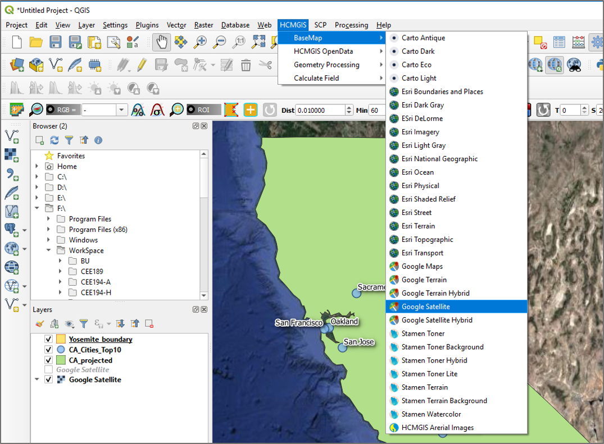

• You can then adjust the transparency (opacity) of the California layer. Right click on the CA_Projected layer and go to **Properties**. In the **Symbology** tab under **Layer Rendering** you can adjust the **Opacity** by sliding the square to the left or typing in a specific opacity on the box on the right. Adjust the opacity to 40. Click **Apply** then click **OK**. Now you can see some of the earth features under the California layer.

• As you may have noticed, the Google Satellite layer may cause QGIS to run a bit slow and can sometimes cause it to freeze. Here is where that regular saving comes in handy! So if you are creating a map it is recommended that you add this layer at the very end of your work. Right click on the Google Satellite layer and click on **Remove Layer.** You can add this layer back after you are done working on individual layer elements.

• Make sure to also **Save** your QGIS project.

• As a final step before you quit QGIS, at the top of your computer, Click on **Project**, then **Properties**. Under the General Settings (in **Project Properties** box) make sure that next to **Save paths** it says **Relative**. This should be the default setting for QGIS, but it is important to check. Relative paths specify the location of the data contained in the map relative to the current location. This means that you should be able to move all the files and the QGIS project to a different folder or computer. However, it is recommended to keep all data in the same location.

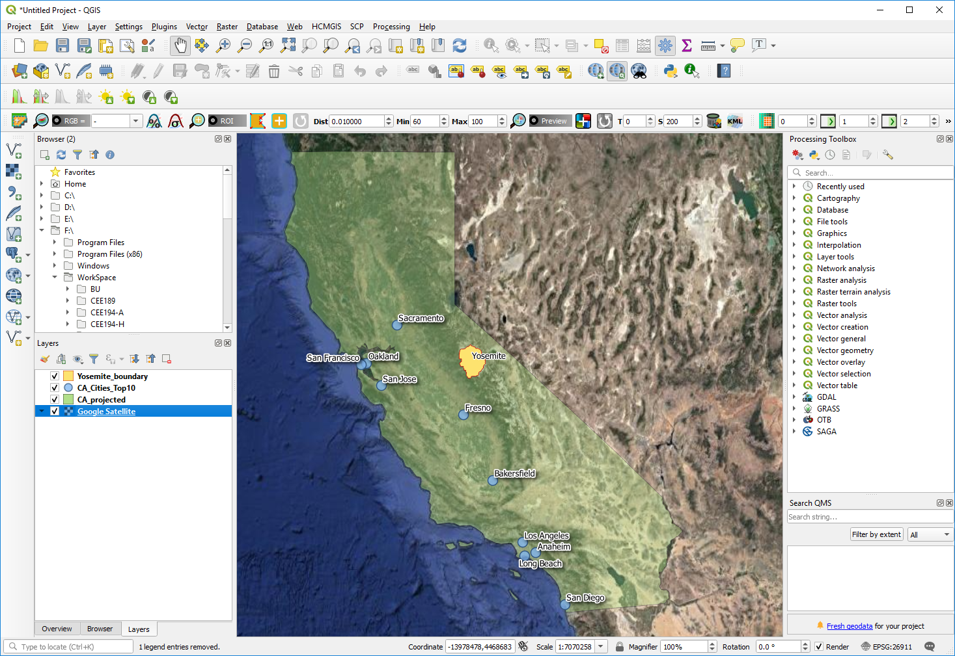

Final map showing all four layers: Yosemite National Park, major cities (with labels), CA State (semitransparent), and Google Earth satellite image in the background.

**Part B: Creating a Map with Print Layout**

The Print Layout function allows you to create a map as a PDF or an image file. You can add all the “pieces” of a map such as adding a legend, scale bar, north arrow, etc. Once you create your first map, you can also save the map template for quick map-making in the future. Let’s briefly explore this tool.

**Compose a Map**

• First open a New Print Layout. From the menu bar choose **Project | New Print Layout** or click the **New Print Layout**  button. Name the layout “Exercise 1” and click **OK**. A new Print Layout window will open.

• Next you will change the **Orientation** of the page to **Portrait**. To change the paper size (default is A4) and other page properties, right click on the blank page and choose **Page Properties** from the menu. The **Item Properties** tab changes to display Page properties. Change the **Paper size** to *Letter* (optional) and set the **Orientation** to *Portrait*.

• On the left hand side of the Print Layout windows, click on **Adds new map to the layout**  button. Then hover over the blank canvas and draw a rectangle about the size of your page. This will automatically display your project properties within the new map. Make sure you leave some space at the top of the page for the title. The legend can be placed to left of California (inside the Pacific Ocean area). To fit the canvas map in the layout frame, click on the **Set Map Extent to Main Canvas Extent**  tool (located right under Map 1 in the **Item Properties** tab).

• The map object can be resized after it has been added by selecting it and using the handles around the perimeters to resize with the **Select/Move item**  tool. This tool lets you select map features such as the map, text, legend etc. When an object is selected, the **Item Properties** tab will show properties specific to that object.

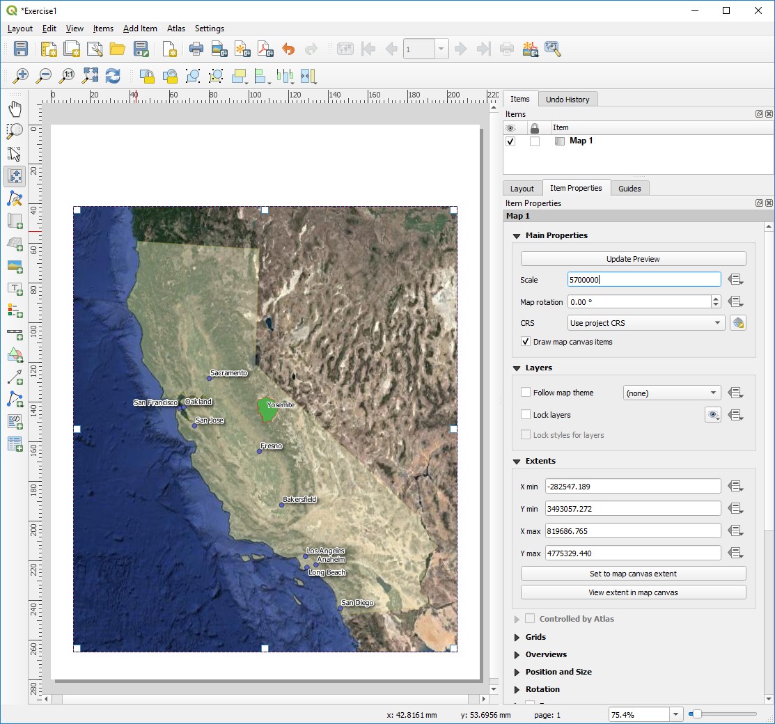

• If California is not centered, click on **Move item content ** button. Then click on the map to move around the content in the map frame without changing the scale. If you need to make adjustments to the scale you can do that in the **Main Properties** section (in **Item Properties** tab). You may need to refresh the map display by clicking on **Update Preview** or using the **Refresh view**  button. (In QGIS 3.8.x you will also find these move item icons right under Map Properties in Item Properties tab).

• Next click on **Add scale bar** (located on the left hand side toolbar). Then click on the lower left side of the map. The scale bar will automatically be displayed. On the right side panel notice how this action automatically updates the **Item Properties**. It now displays properties of the scale bar. In the **Style** option under **Main Properties**, choose **Line Ticks Up**. Under **Segments**, decrease the left to 0 and the right to 2. Under **Fonts and Colors**, change the fill color to white by clicking on the triangle to expand the options and choosing white. Under **Background**, check the box and change the background color to white.

• To add a legend click on **Add new legend**  (located on the left hand side toolbar). Drag the legend box to the low left side of the map above the scale bar. To resize the legend you may need to uncheck the **Resize to fit contents** box under **Main Properties** (in Item Properties). Notice how the legend lists the names of map layers as displayed in the **Layer Panel**. The layer names match the names of the shapefiles by default. If you want to rename the map layers you need to do this in QGIS Layer Panel (you won’t be able to change the names in the legend window). While keeping your Print Layout window open, go to QGIS Layers Panel and right-click on the shapefiles you want to rename. Choose **Rename Layers** and enter a meaningful name (e.g. Yosemite National Park, CA Main Cities, CA State etc.). This should automatically update the legend names (if not check/uncheck the **Auto update** box under **Legend Items** in **Item Properties**). Alternatively, you can click the name of the layer listed under Legend Items (in Item Properties). This will open the Item text box where you can edit the name of the layer.

• The last item is to add the map title. Use the **Add new label**  tool to drag a box all the way across the top of the page layout canvas. The text box can be resized by using the graphic handles. By default the placeholder text *Lorem ipsum* appears. Overwrite the default text and choose any title you find appropriate. Position the text in the center of the textbox, resize the text, change the font etc. using the options available under **Label** in **Item Properties**. As a final step you can check out all the other features of the **Print Layout**. You can style your maps to fit your cartographic needs.

• To end this exercise, we will save the map as a pdf. At the top of your screen, click on **Layout**, then **Export as PDF** or clickthe **Export as PDF**  tool. A screen may pop up saying something about *WMS servers and that printing layers from such servers may exceed this limit*. If so, close the message screen. The Export to PDF appears. Navigate to your course folder and name your map *Exercise1 Map*. The PDF Export Options window pops up, leave the default settings unchanged and click **Save**. Alternatively you can export the map as an image. For this option click the **Export as image**  button and choose the image format you wish to save your map. You can then open the exported map file and take a look at the map you created. Before exiting QGIS make sure you save your project. Next time you start your saved Exercise1 QGIS session you can always come back to the Print Layout you by selecting **Project | Layouts | Exercise1**.